Terms of Reference (ToR)
Forest Investment Consulting

Background
Uruguay XXI, as the institute in charge of promoting Uruguayan investments and exports, has adopted a strategy of prioritizing sectors for the promotion of investments; such is the example of the Forestry-Wood sector.
By hiring a private consultancy, the Institute conducted a "baseline analysis of the Uruguayan Forestry-Wood sector". The objective of it was to contribute to the first phase of the prospective study of the forestry-wood sector, for which OPP hired the Finnish Technological Center VTT. The final phase consists of preparing a roadmap for the defined Forestry Bioeconomy Areas (FBA). In this sense, from the Investment Promotion Department of Uruguay XXI it was defined to support the strategy of external insertion by attracting foreign investment.

Objectives
To have an investment promotion plan in the Forestry value chain. To accomplish this and based on the FBAs defined in the framework of the OPP-VTT prospective (see annex), it is necessary to identify in which segments of the value chain there is potential and/or need to attract foreign investment, recognize which investment form would be more attractive and convenient for the development of the sector. Additionally, it is necessary to develop a value proposal, as well as identify in which markets the potential investors are, propose promotion activities and provide a list of potential targets to start the promotion activities. Additionally, it is expected to identify key players abroad that can act as multipliers or developers for the sector in Uruguay.

- Profile
Consultant or consulting firm. The consultancy should be led by a university professional with education in Economic Sciences, Agricultural Engineering, Industrial Engineering or similar.
It will be especially valued:
- Knowledge of the Uruguayan and international Forestry sector.
- Postgraduate degrees in subjects related to the purpose of the call for applications
- Experience in sectorial diagnostics.
- Experience in preparing plans, programs and projects related to investment promotion.
- Knowledge in strategic and prospective planning.
General Competences
- Commitment and Proactivity (initiative)
- Teamwork
- Ability to work with external agents of the organization.
- Excellent communication and dialogue skills.
- Activities
- Analyze the information available in the sectorial diagnosis and other relevant documents of the forestry value chain, according to the specific objectives of this consultancy.
- Carry out interviews with key actors.
- Process primary information.
- Analyze the intermediate results together with the Uruguay XXI team.
- Presentation of the promotion plan in activities associated with the sector promotion planning.
- Maintain ongoing communication and dialogue with the Investment Promotion Management, both through electronic means (email, Skype / others, video conference) and face-to-face (meetings, workshops).
- Provide documentation and materials of interest for the development of the study, as well as relevant contacts.
- Prepare the requested reports detailing the proposed promotion plan and strategy, as well as the value proposal.
- Participate in a inward mission to Uruguay to hold meetings with relevant actors in the sector (in the case that the consultant resides abroad).

- Period
Three months since the signing of the contract, with the possibility of an extension for a further two months.
- Products
I. Detailed work plan and schedule of deliverables. 15 days after the start of the consultancy. The work plan should include in detail the scope, limits and work schedule, with attention to the contents requested in the reports.
  - First report: 45 days
  - Second report: 60 days
  - Third report: 90 days
- Reports
  - First Report: Systematization of diagnosis.
    - Systematize the existing information on the investment flows of the forest-wood chain at the international level, with special attention to the origin, destination, modality, and trends.
    - Identify the motivating factors of investment flows and the main criteria considered by investors in order to evaluate projects in the sector. Recommend how Uruguay could preempt these factors and address these criteria.
    - Identify and prioritize in the framework of the selected FBAs, the sectors of the chain and segments in which there is greater need and more opportunity to attract foreign investment.
    - Identify short-term development needs of the selected sectors and segments in order to be attractive for foreign investment

  - Second Report: Draft of the value proposition of the forestry-wood sector and strategic investment attraction plan.
    - Present a value proposal for investment attraction, including the potential benefits of investing in the Forestry-wood sector in Uruguay. Presenting the basic elements of the business case for investing in the Uruguayan forestry industry.
    - Identify possible modalities of Uruguay's insertion in the global investment trends of the Forestry sector, taking into account existing and potential foreign investments. Present where the emphasis of the investment promotion strategy should be.
    - Identify the necessary improvements in the business climate so as to enhance the value proposition and / or attract investments in the sector.
    - Identify potential sources of investment, markets to address, and provide a list of 30 potential targets.
    - Propose potential markets where to carry out the activities related to the promotion of the sector, as well as events to participate in the framework of a plan to promote the sector and attract potential investors.
    - Identify key actors not only abroad but at the local level, in order to involve them in the promotion and in the development strategy of the sector.
- Third Report: Final report on the value proposition of the sector and the strategic plan for attracting investments.
    - Present the final document of the value proposal. This document should serve as an input for the preparation of a promotional business case and other promotional materials.
    - Present an investment promotion strategy, presenting markets and potential target companies, as well as a series of recommended activities to be carried out. The investment promotion plan must have a timeline and a cost estimation of the proposed actions, as well as recommendations about information to be handled by the promotion team.

- Contractual relationship and dedication
The modality will be: contracting of services. The time commitment will be determined by the deadlines for delivery of the expected results of the consultancy.

- Budget and method of payment
The amount of the consultancy will be up to USD 40,000 (forty thousand American dollars) taxes included. Additionally, up to USD 4,000 (for thousand American dollars) shall be financed for transport and stay, in case that an inward mission to Uruguay in considered applicable.
The fees will be paid according to the following detail:
- 20% upon approval of the Work Plan
- 30% upon approval of the Second Report
- 50% upon approval of the Third Report

- Coordination and supervision
The work will be coordinated by Uruguay XXI.
The products that arise from this technical assistance will be subject to approval of Uruguay XXI, providing an instance of feedback to the consultant, irrespective of that the work will be carried out through a permanent communication and dialogue with the technical team of the Institute.

- Reserved Information
The copyright of the documents produced will be property of Uruguay XXI, for which the consultant will not be able to share or disseminate the information produced in this consultancy with other organisms or persons.
Uruguay XXI, may have the documents and results of this consultancy, for the use it deems appropriate.

- Selection and qualification procedure

Presentation of CVs, background and methodological proposal.
- Only the background information which can be accredited by documents must be included in the CV, these documents will not be required in the first instance.
- A preliminary timeline proposal.
The consultant will be selected from a list of candidates sorted according to the scores obtained in the selection process (comparison of grades).

For the evaluation of the CVs, the following will be taken into account:

a. Training
b. Work experience

Only those applicants who meet the minimum requirements requested will be considered.
The relative weight for each item will be the following:

- Training and Experience- 60 points
- Proposed timeline - 15 points
- Interview - 25 points
Each item is exclusive, therefore you cannot have 0 (zero) point in any of these. The minimum score to pass to the interview phase is 45 points

- Notifications
All communications will be send to the electronic mail that the candidate declared at the time of the application. After five working days from sending the communication or the time stated in the communication itself, it shall be considered as notified for all purposes.
If upon receiving the notification of having been selected, the interested party does not present within the established period, it will be understood as though he/she has withdrawn from the application process, which will entitle the contractor to call the next person on the order of precedence of the list of selected candidates if determined by the process.

- Eligibility Criteria
The consultant must comply with the following requirements:
If you are a civil servant (with the exception of public school teachers):
- Be on a period of unpaid leave
- Not having worked with the contractor during the period immediately prior to the start of his leave; and
- The contract does not lead to a conflict of interest.

Not to have work or family relationship with any member of the contracting party (or executing unit) personnel who are directly or indirectly involved with any part of:
- The preparation of these ToR;
- The selection process; and/or
- The supervision of the work.
Not having another full time contract on any project that prevents the fulfillment of activities within these ToR.
Were to be relative (up to the third degree of consanguinity or adoption or until the second degree by marriage or cohabitation) of any staff member of Uruguay XXI, the consultant shall inform the Contracting Party, who must be in knowledge and express their approval prior the formalization of the procurement

- Term and presentation
Please send your updated CV and project timeline proposal according to paragraph 11 of the present terms of reference, to the mailbox forestry@uruguayxxi.gub.uy, indicating the call of reference on the subject.

The deadline for applications is August 29th 2018.

ANEXO. Description of FBAs provided by VTT-OPP

Forest-based bioeconomy areas (FBAs) are the cornerstones of forest cluster, which relies on sustainable and resource-efficient use of forest biomass. The emerging forest-based bioeconomy builds on the traditional forest industry. Five key forest-based bioeconomy areas include forest management, mechanical wood processing, fibre-based biomaterial processing, biorefining and bioenergy, Figure 1.

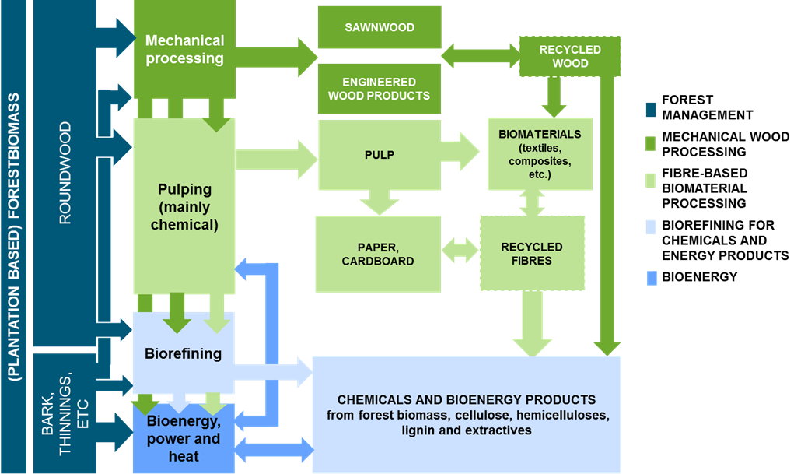

Figure 1. Biomass flows, processes and potential products within the five Forest-based Bioeconomy Areas focused on in the project.

FBA 1: Forest management
Forest-based biomass is in the centre of all economic activities related to forest-based bioeconomy. Forest management has long-term impacts on future forest biomass, not only the availability and sustainability but also the quality and costs of wood. Ensuring the raw material base for various processes and applications is a key of any future bioeconomy business. Forest management focuses on sustainable forestry activities related to for example silviculture, tree breeding and forest biotechnologies, forest inventory and technologies used in inventories (e.g. techniques utilising satellite data and/or laser scanning), harvesting and transportation of wood-based biomass. Development of intelligent forest machinery as well as digitalisation and use of digital platforms are cross-cutting technologies which are increasingly important in any of the above mentioned areas.

FBA 2: Mechanical wood processing
Mechanical wood processing focuses on mechanical transformation of wood to versatile structural and non-structural products, such as sawnwood, veneer, plywood, furniture, construction elements and vehicle industries. Sawmilling is in a focal point of mechanical wood processing value chain along with manufacturing of engineered wood products. Mechanical wood processing is linked with other forest-based bioeconomy areas, as side-streams from mechanical transformation of wood are used in bioenergy production, chemical pulping and biorefining. Sawdust, which is residue of sawmilling, can also be used as an important element in good tree nursery substrate and animal bedding and landscaping material.

FBA 3: Fibre-based biomaterial processing
Traditionally the focus in this forest-based bioeconomy area has been in pulp, paper and fibre-based packaging production. Yet, other types of biomaterials have also been produced, such as wood-based textile fibers. Recently, new forms of value-added wood fibre-based biomaterials have being developed. These novel types of biomaterials include foams, new kinds of textile fibres and yarns and (bio)composites. The progress requires not only development of pre-treatment and pulping technologies but also advancements in fibre and web technologies and processing of biomaterials - the latter be considered as potential game changers. Technologies applied today in pre-treatments, pulping and packaging production are to large extent mature, but with future viability. For example, the current main technology in chemical pulping, kraft process, most probably continues to be dominating technology in coming 15 to 20 years at least.

FBA 4: Biorefining
Whereas FBA 3 concentrates on fibre-based biomaterials, the focus in biorefining is in manufacturing value added biochemical and bioenergy products from forest biomass. Circular bioeconomy approach emphasizes the role of industrial symbioses and utilization of industrial by-products and side-streams in biorefineries. The key technology areas related to biorefining include pre-treatments, pulping, conversion, separation and bioprocessing technologies, application of industrial biotechnology and processing technologies for biopolymers.

FBA 5: Bioenergy
Bioenergy is an integral part of forest-based bioeconomy. Wood-based bioenergy can be produced by using residues from harvesting and mechanical wood processing. It also plays an important part of integrated pulp mills and biorefineries. Thermochemical conversion technologies, like gasification, combustion and co-firing, pyrolysis, gas/liquid fermentation, acid and enzymatic hydrolysis, and metabolic engineering enable production of variety of bioenergy and chemical products from forest biomass. Established, ‘safe bet’ technologies in bioenergy production include pelletizing and briquetting, gasification, combustion and co-firing and pyrolysis. Emerging technologies relate more to acid and enzymatic hydrolysis and fermentation, metabolic engineering, bio-char production (torrefaction), steam explosion and biodiesel post-processing.

